Customer Shopping Behavior Analysis
1. Project Overview
This project analyses customer shopping behaviour using
transactional data from 3,900 purchases across various product
categories. The goal is to uncover insights into spending patterns,
customer segments, product preferences, and subscription
behavior to guide strategic business decisions.

2. Dataset Summary
- Rows: 3,900
- Columns: 18
- Key Features: - Customer demographics (Age, Gender, Location, Subscription Status)
-Purchase details (Item Purchased, Category, Purchase Amount, Season, Size, Colour)
- Shopping behavior (Discount Applied, Promo Code Used, Previous Purchases, Frequency of Purchases, Review Rating, Shipping Type)
- Missing Data: 37 values in Review Rating column.

3. Exploratory Data Analysis using Python
began with data preparation and cleaning in Python:
. Data Loading: Imported the dataset using pandas
. Initial Exploration: Used df.info() to check structure and .describe() for
summary statistics.

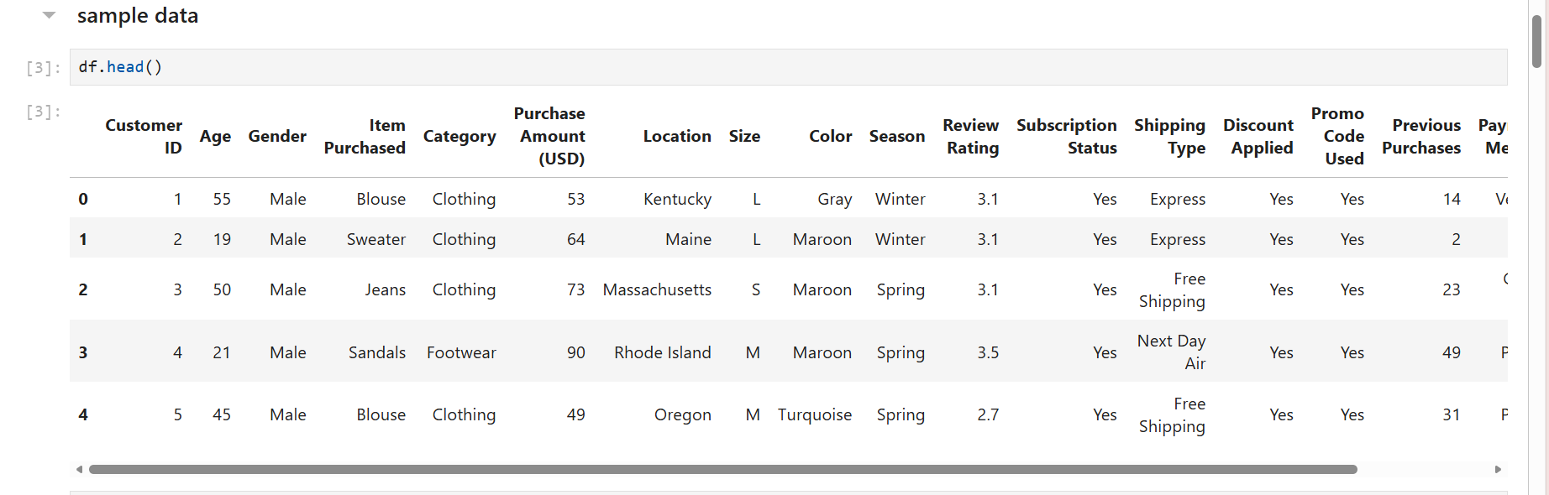
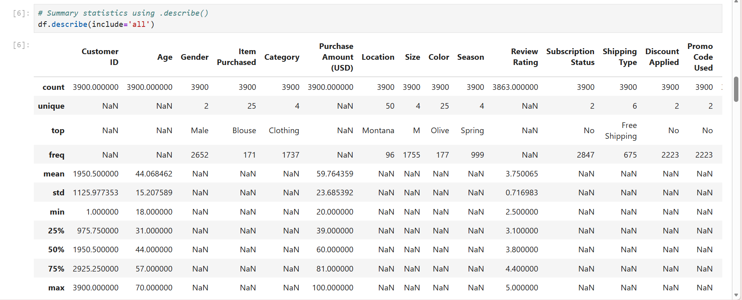
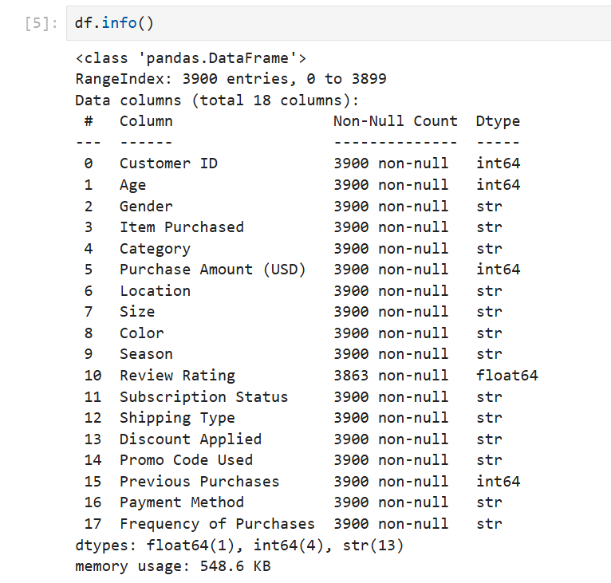

- Missing Data Handling: Checked for null values and imputed missing values in the
Review Rating column using the median rating of each product category.
- Column Standardization: Renamed columns to snake case for better readability and documentation.
- Feature Engineering: Created age_group column by binning customer ages.
- Created purchase_frequency_days column from purchase data.
- Data Consistency Check: Verified if discount_applied and promo_code_used
were redundant, dropped promo_code_used.
- Database Integration: Connected Python script to MySQL and loaded the cleaned Data Frame into the database for SQL analysis.

4. Data Analysis using SQL
We performed structured analysis in MySQL to answer key business questions.
- What is the total revenue generated by male vs. female customers?
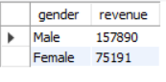
- Which customers used a discount but still spent more than the average purchase amount?
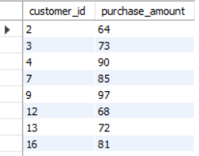

- Which are the top 5 products with the highest average review rating?
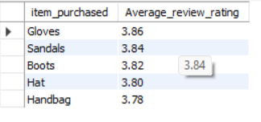

- Compare the average Purchase Amounts between Standard and Express Shipping.
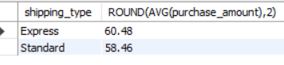

- Do subscribed customers spend more? Compare average spend and total revenue between subscribers and non-subscribers.
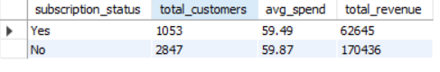

- Which 5 products have the highest percentage of purchases with discounts applied?
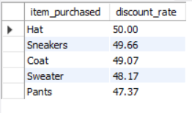

- Segment customers into New, Returning, and Loyal based on their total number of previous purchases, and show the count of each segment.
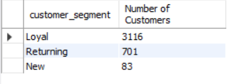

- What are the top 3 most purchased products within each category?
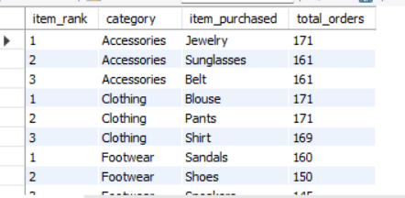

- Are customers who are repeat buyers (more than 5 previous purchases) also likely to subscribe?
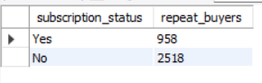

- What is the revenue contribution of each age group?
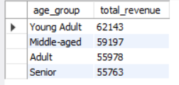

- which age group generates the lowest revenue?
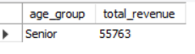

- What is the average purchase amount for each age group?
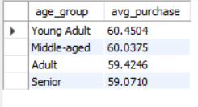

- which gender generates the lowest revenue?
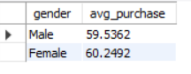

- which age group has the highest number of purchase?
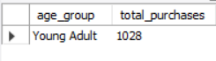

- which age group shops most frequently?
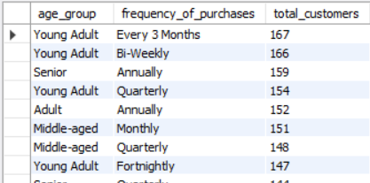

- which gender gives the highest average review rating?
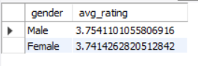

- Which age group tends to purchase more premium items?
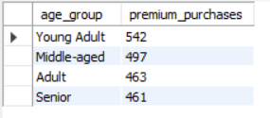

- Which item is purchased the most?
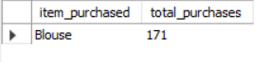

- .Which item generates the highest revenue?
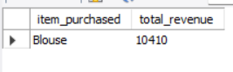

- Which category has the highest sales revenue?
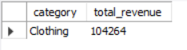

- Which category has the lowest sales revenue?
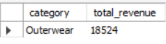

- What is the average purchase amount by category?
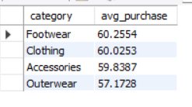

- Which product has the lowest average rating?
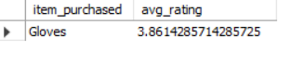

- Which category has the highest number of customer ratings?
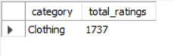

- Which product category is most frequently purchased by repeat customers?
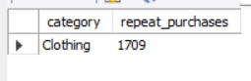

- Which product performs best during each season?
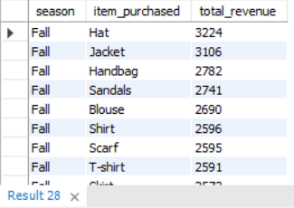

- Which item is most popular among subscribed customers?
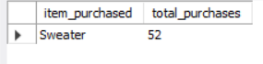

- Which product category attracts the highest spending customers?
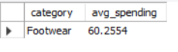

- Which items are most frequently purchased when discounts are applied?
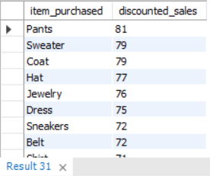

- Which category has the most consistent sales across seasons?
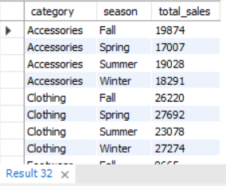

- What is the total revenue generated from all purchases?
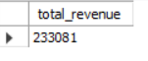

- Which location generates the highest revenue?
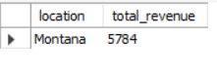

- Which location generates the lowest revenue?
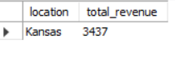

- Which season generates the highest total revenue?
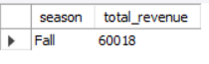

- Which season generates the lowest total revenue?
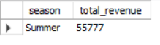

- Which location has the highest number of transactions?
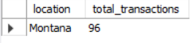

- Which location has the lowest number of transactions?
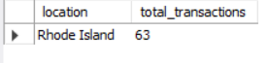

- Which product size generates the highest revenue?
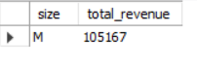

- Which color generates the most sales revenue?
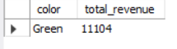

- Which size has the lowest demand?
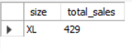

- .Which location generates the highest number of high-value purchases?
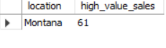

- Which customers have the highest number of previous purchases?
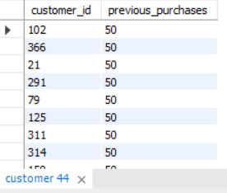

- Which frequency of purchase category is most common?
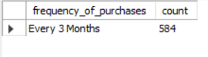

- Which frequency group generates the highest revenue?
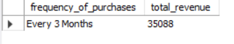

- Which customers purchase most frequently without subscription?
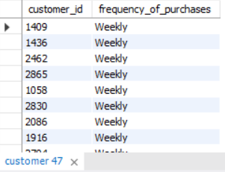

- Which customer type spends the most but does not use discounts?
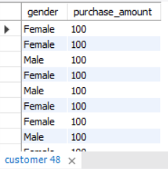

- Which age group prefers which color the most?
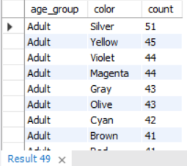

- .Which purchase frequency group has high sales but no subscription and no discount?
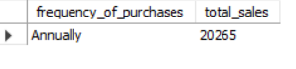

- Which customers with subscriptions purchase more frequently?
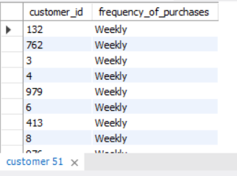

- Which age group has the highest repeat purchase rate?
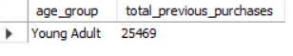

- Which product category is most popular among repeat customers?
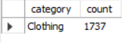

- Which customers give high ratings but purchase less frequently?
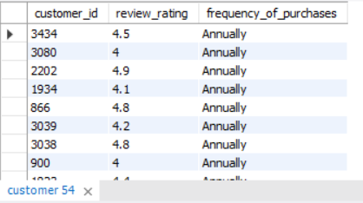

- Which customer segment contributes most to loyalty purchases?
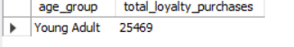

- Which customers have high previous purchases but low current spending?
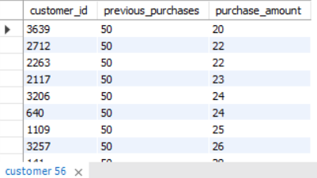

- How many customers used discounts?
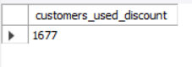

- How many customers purchased without discounts?
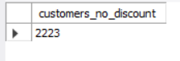

- Which product category benefits the most from discounts?
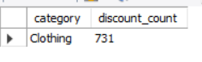

- Which locations have the highest discount usage?
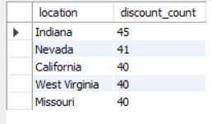

- Which age group uses discounts the most?
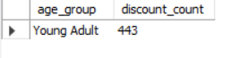

- Which products are most often bought with discounts?
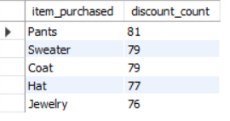

- What percentage of customers have active subscriptions?
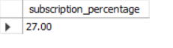
- Which subscription customers purchase most frequently?
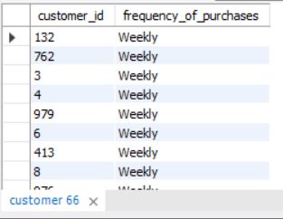

- Which locations have the highest subscription rates?
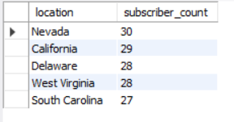

- Which product categories are most popular among subscribers?
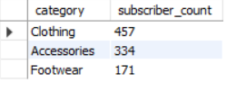

- Does subscription increase repeat purchases?
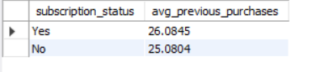

- Which product categories are un-popular among subscribers?
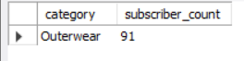

- Which payment method is used most frequently?
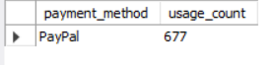

- Which payment method generates the highest revenue?
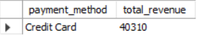

- Which payment method generates the lowest revenue?
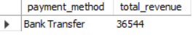

- Which payment method is preferred by subscribed customers?
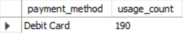

- Which shipping type is used most often?
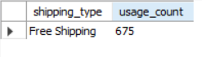

- Which shipping type generates the highest revenue?
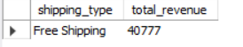

- Which locations prefer faster shipping options?
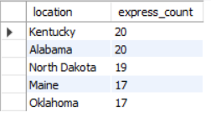

- Which product categories are mostly shipped via express shipping?
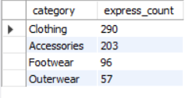

- Which shipping type is most common among repeat customers?
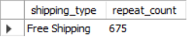

- Which payment method is most common among discount users?
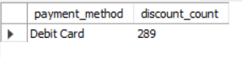

- Which payment method is preferred in each location?
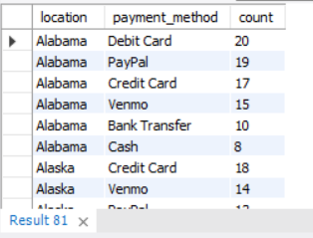

- Which shipping option is most used during high sales seasons?
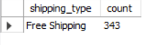

- Which product category has the highest customer rating?
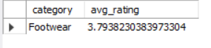

- Which combination of age group and category generates the highest revenue?
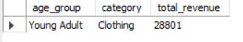

- Which location prefers which product category the most?
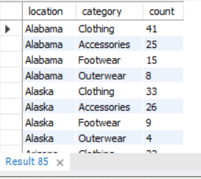

- Which customers give high ratings but spend less?
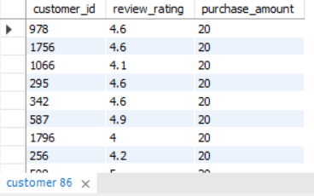

- Which categories perform best in each season?
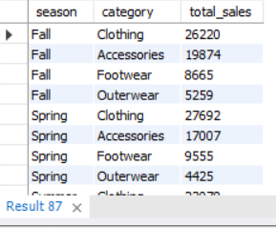
- Which color is most popular in each season?
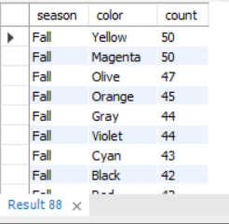

- Which size is most popular in each category?
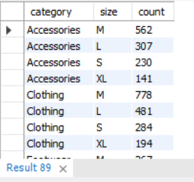

- Which customer segments contribute most to seasonal sales?
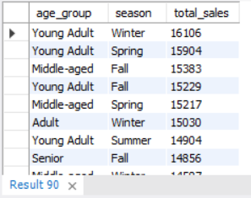

- Which product categories grow fastest in repeat purchases?
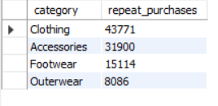

- Which customers spend more during specific seasons?
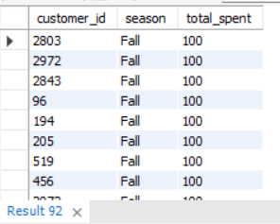

- Which locations show the highest growth in repeat purchases?
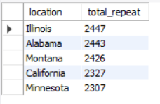

- Which combination of category, colour, and season generates the highest revenue?
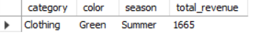

5. Visualization
Power Bi Dashboards

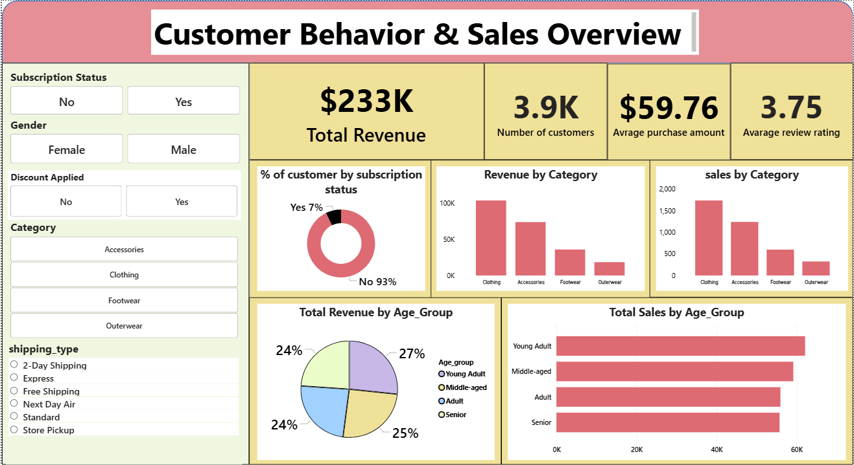

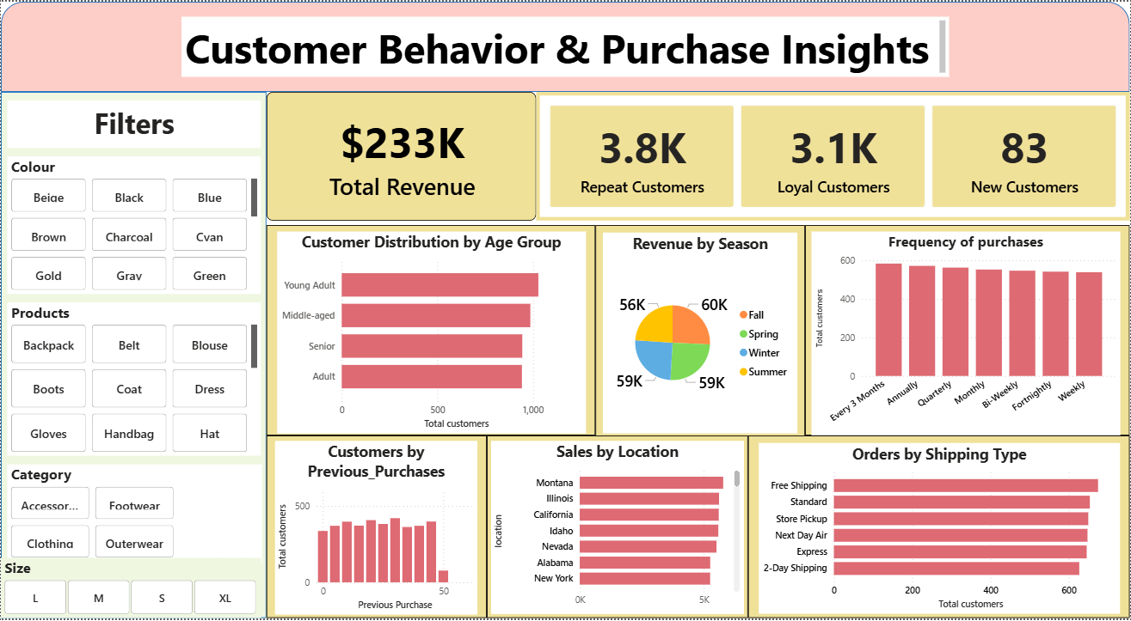
Strategic Business Recommendations
1. Strengthen High-Revenue Customer Segments
Customers in the highest revenue-generating age groups and locations should be prioritized with targeted marketing campaigns.
Recommendation
- Launch personalized offers and loyalty programs for high-spending demographics.
- Provide exclusive deals or early access to products for high-value customers.
Business Impact
- Increases customer lifetime value (CLV)
- Improves customer retention and repeat purchases

2. Convert Frequent Buyers into Subscribers
The analysis explores subscription vs non-subscription spending behavior.
Recommendation
- Offer subscription incentives such as:
  - Exclusive discounts
  - Faster shipping
  - Loyalty rewards
- Target repeat buyers with more than 5 purchases for subscription conversion.
Business Impact
- Higher predictable recurring revenue
- Increased customer loyalty

3. Optimize Discount Strategy
The dataset evaluates discount usage, promo codes, and product sales with discounts.
Recommendation
- Apply discounts only to slow-moving products or low-revenue categories.
- Avoid excessive discounts on high-demand products.
Business Impact
- Protects profit margins
- Improves inventory turnover

4. Focus on Top-Performing Product Categories
Your analysis includes:
- Highest revenue categories
- Most purchased items
- Highest average purchase value by category.
Recommendation
- Increase inventory and marketing investment in top-performing categories.
- Introduce product bundles within these categories.
Business Impact
- Drives higher sales volume
- Enhances cross-selling opportunities

5. Improve Low-Performing Categories
Some categories generate low sales revenue or low demand.
Recommendation
- Use seasonal promotions or limited-time offers.
- Evaluate if these categories should be repositioned or discontinued.
Business Impact
- Reduces inventory costs
- Focuses resources on profitable categories

6. Seasonal Demand Planning
Your project analyzes seasonal sales and product popularity by season.
Recommendation
- Increase stock for high-performing seasonal products before peak season.
- Run season-specific campaigns (e.g., winter clothing promotions).
Business Impact
- Prevents stockouts
- Maximizes seasonal revenue

7. Shipping Strategy Optimization
Your SQL questions analyze shipping type vs purchase amount and usage frequency.
Recommendation
- Promote Express Shipping for high-value orders.
- Offer free express shipping for premium customers or subscribers.
Business Impact
- Enhances customer satisfaction
- Encourages higher purchase value

8. Location-Based Marketing Strategy
The dataset includes location revenue and transaction analysis.
Recommendation
- Focus marketing budgets on high-revenue locations.
- Use localized promotions for low-performing regions.
Business Impact
- Improves regional sales performance
- Optimizes marketing spend efficiency

9. Improve Customer Experience Using Reviews
Your dataset includes customer ratings and review analysis.
Recommendation
- Investigate products with low average ratings.
- Improve product quality, description accuracy, or customer service.
Business Impact
- Improves customer trust
- Increases future sales and brand reputation

10. Target Repeat Customers with Loyalty Programs
Your project includes customer segmentation (New, Returning, Loyal).
Recommendation
- Create tier-based loyalty programs:
  - Silver: Returning customers
  - Gold: Loyal customers
  - Platinum: High spenders
Business Impact
- Encourages repeat purchases
- Builds long-term customer relationships

